*ADAPTIVE BASKETBALL COACH*

Final Project DGMD S-14

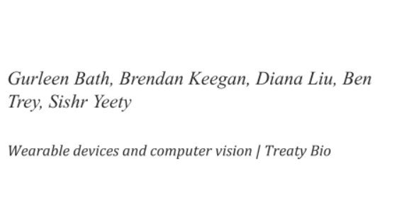

**Table of Contents**

**INTRODUCTION 1**

[**COMPUTATIONAL DISCUSSION 1**](https://docs.google.com/document/d/18kRTMLjT_9e2Ec691Eyla2kIBNVhvxkk/edit#heading=h.30j0zll)

[**ALGORITHMIC DISCUSSION 2**](https://docs.google.com/document/d/18kRTMLjT_9e2Ec691Eyla2kIBNVhvxkk/edit#heading=h.1fob9te)

[**IMPLEMENTATION AND ARCHITECTURE PRESENTATION 3**](https://docs.google.com/document/d/18kRTMLjT_9e2Ec691Eyla2kIBNVhvxkk/edit#heading=h.3znysh7)

[Architecture 3](https://docs.google.com/document/d/18kRTMLjT_9e2Ec691Eyla2kIBNVhvxkk/edit#heading=h.2et92p0)

[Implementation 4](https://docs.google.com/document/d/18kRTMLjT_9e2Ec691Eyla2kIBNVhvxkk/edit#heading=h.tyjcwt)

[**CONCLUSIONS 5**](https://docs.google.com/document/d/18kRTMLjT_9e2Ec691Eyla2kIBNVhvxkk/edit#heading=h.3dy6vkm)

## 

## INTRODUCTION

If Lebron James and I were to square up on the court, the outcome would seem intuitively predictable. Still, one might ask what makes James dominate the court? Even though we recognize it as a learned skill, the question remains: How does a basketball player shoot a successful shot? And how can scientific technologies including wearable device technology and machine learning inform our understanding to coach others toward the enhancement of this skill? In this paper, we present a theory and set of corresponding hypotheses that combine machine learning, computer vision, and digital signal processing to supply a further understanding of the basketball shooting process. Without proper coaching, it is easy to continue to affirm the same physical conditioning that will further reward poor shooting form. Further, frequent practice of movements that will improve shooting success, will help to condition the shooter’s likelihood to repeat those movements when it really matters most—in competition. An application that provides custom coaching to a shooter and also accommodates his practice as often as he likes, holds much potential to improve his basketball performance. While many orate that they could improve their shooting performance if they had more practice time under the direction of their own shooting coach, this project endeavors to create an application that factors in adaptability to unique court locations and shooting style while also mentoring the shooter toward improvement in her successful shot performance rate. This paper reports on the work of team Treaty Bio’s progress in the development of a wearable device during its Summer 2020 collaboration effort. As I reflect on the theory, algorithms, hypotheses, architecture, findings, and conclusions of our Adaptive Basketball Coach (ABC) application, I consider accomplishments and possible future directions for further development. Ultimately, we hope to provide an application that makes basketball coaching much more personalized and accessible to the player.

**COMPUTATIONAL DISCUSSION**

In many cases, there are key components we can recognize in shooting form as related to success on the court. For example, we know of the importance the movement of the wrist plays in shot success. If this is the case, then can’t we simply find data to ascertain key shooting positions for winning outcomes? We contend this is not enough as it eliminates the needed fluidity and adaptability of the players on the court. While we understand there are key components of the form worthy of study, the optimal use of those components may vary from one player to the next and even more some in how they are used in synchronization. For example, one player may successfully use more acceleration from the arm in exchange for less acceleration in the knees. Our interest is in providing coaching that adapts to the optimal form for the likelihood of successful shots at the individual shooter’s level. That is, we endeavor to create a wearable device that coaches the individual for best results and that recognizes that different persons may ideally rely on their own strengths while minimizing their weaknesses. Further, why don’t we just create a device that trains the shooter on a single shooting episode? While this may have its purpose, it misses ours in that we want something more adaptable. For example, a typical athlete will practice free throws and jump shots from various spots on the court all within a single practice session. We would like our device to be able to train to each shooting episode and understand that the form and motions needed for success for a free throw will differ from a corner three-point shot. So, this device is best suited for the athlete interested in practicing a shot-possibly at different spots on the court-but with repeated practice attempts.

**ALGORITHMIC DISCUSSION**

In this section, we discuss the Adaptive Basketball Coach algorithm per Treaty Bio’s current team progress. Treaty Bio includes Gurleen Bath, Brendan Keegan, Diana Liu, Benjamin Trey, and Sishir Yeety. Their roles and responsibilities are provided in Chart 1, below.

Chart 1, Treaty Bio Team Membership: Roles and Responsibilities[[1]](https://d.docs.live.net/1e7f28ea918a48a3/Desktop/DGMD_14/Project/DGMD_S_14_Liu_Final_paper.docx#_ftn1)

[[1]](https://d.docs.live.net/1e7f28ea918a48a3/Desktop/DGMD_14/Project/DGMD_S_14_Liu_Final_paper.docx#_ftnref1) Each person’s primary role within the team is in bold within the listing of their responsibilities.

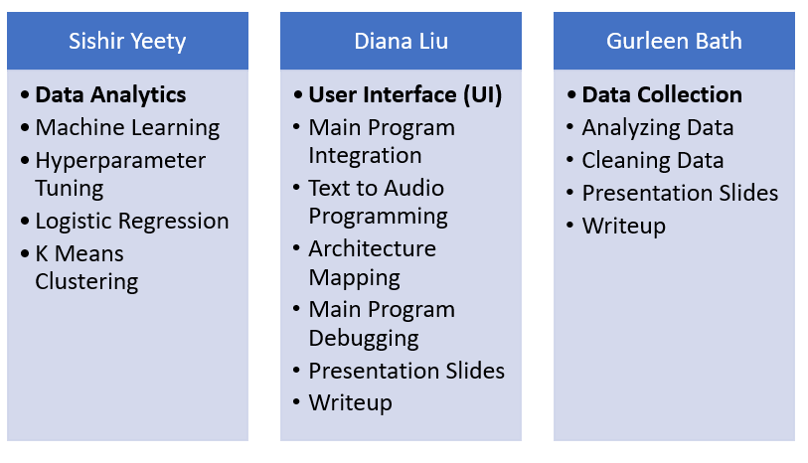

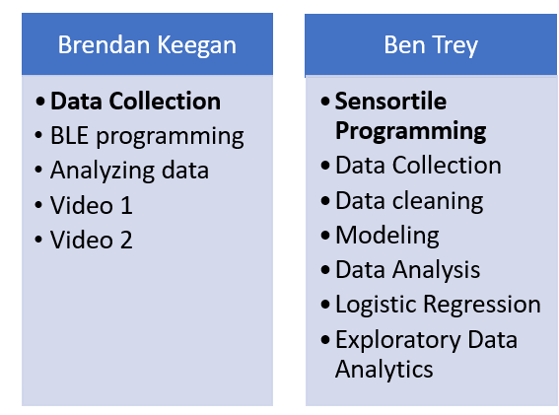

As we discuss the algorithm, we can also see the unique contributions and perspectives that each of the team members made to ultimately bring ABC together. So, we observe the algorithm in terms of our unique contributions to show how, ultimately, the pieces of our team’s puzzle fit together to make the picture that is ABC in its entirety. Step 1 of the Algorithm commences with a command that initiates the data collection process. Diana’s primary responsibility was developing the User Interface (UI) for the application. Since the team wanted an application that ultimately could move to an Android/IOS device, we wanted the UI to be kept very clean, simple, and user-friendly. Also, since it makes sense for a basketball player to shoot with hands on the ball rather than required to prompt text into the device, Diana tried to work toward the development of UI for a wearable device that could be near or on the player and activated with a hands-free, audio command. For these reasons, our UI requires the tap of a button to initiate “capture.” From there, the UI allows reliance on audio commands and audio feedback aims for real-time feedback and for a mostly hands-off experience. See Image 1, below, to see the UI Diana worked on and also provides a visual of the process of our voice-prompted algorithm from “capture” which initiates the data collection to “exit” which closes the application.

**Image 1: User Interface (UI)**



In result, as shown in Figure 1 below, our algorithm initiates with a verbal command such as “capture” to initiate data capture. Next, the shooter shoots the ball while wearing a sensor. Brendan and Gurleen’s primary roles were data collection (see the Implementation section for further details) and each worked on this data collection portion. Gurleen's role also included data cleaning. We tried different methods to combine the two files in different ways, such as combining all the shot data or collating individual shot data into max/min and then compared to see what runs best in our model. Ben’s primary role was sensortile programming so that, for example, the application is programmed for its steps in digital signal processing once the shooter takes the shot. Brendan programmed our BLE data process that assists in transmitting the data to our Python model(s) for cleaning and analytics. At this point, Ben and Sishir’s analytics and Sishir’s machine learning program instruct inferences drawn from the data and the mentorship returned to the basketball player. Does the player need to bend the knees more or turn the wrist more? Our application decides on motions that the player should adjust to increase the likelihood of several shot successes and instructs the player on the finding. Diana also programmed the UI to return the mentorship through a text as well as verbal/audio command from the device.

Figure 1, below, shows the current algorithm process:

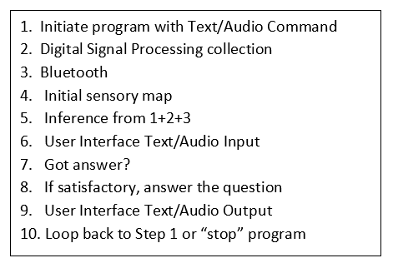 Figure 1: Algorithm 1

As the user repeats more shooting episodes, the application is programmed by Ben in its analytics to employ Figure 2 (below) algorithm which will include previous shooting history into the shooting algorithm.

Figure 2: Algorithm 2

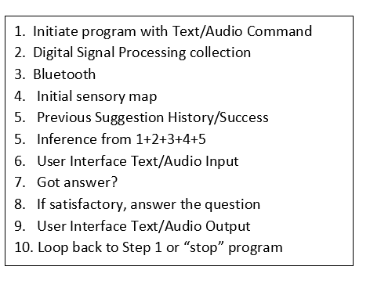

Sishir Yeety focused his work in the areas of data collection and machine learning. In Figure 3, below, you can see the Machine Learning Sequence Sishir would initiate for our application. This machine learning portion of our overall algorithm begins with data collection from our sensors. Once data is acquired, we employ clustering by the use of K means. Then, we begin logistic regression on the fitted model(s) and return model feedback to the user of the application. Libraries used in the process include scikit-learn, numpy, pandas, and matplotlib for visualization.

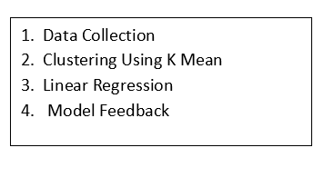**Figure 3: Machine Learning Sequence**

|  |  |
| --- | --- |
|  |  |
|  |  |

**IMPLEMENTATION AND ARCHITECTURE PRESENTATION**

**Architecture**

**Figure 2: Architecture Display**

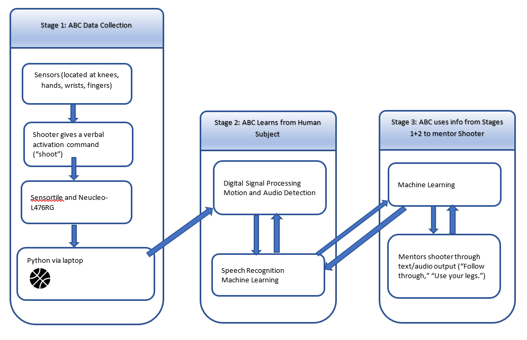

At this point, this architecture (Figure 2) is quite supervised in its process, but in time, there may be an opportunity to make it less supervised. For the time being, the process initiates with a specified spoken or text command. Then, the sensor (placed on the back of the hand, knees, wrist, or head) will begin to collect data as the basketball player shoots the ball. Through digital signal processing in connection with Bluetooth technology, the collected data feeds into the initial Python sensory map. Once there, ideally, the sensor data will synchronize. At this time, our algorithm does not fully complete synchronization successfully but we are bringing in the inputs from each sensor individually. Next, we perform analytics through SkLearn in Python and based on those analytics, if there is a satisfactory answer to inform shot success rate, we deliver the coaching advice from the machine to the basketball shooter through the user interface (UI) with text/audio output. Following this step, we use a machine learning process that allows us to loop back to step one and continue through the algorithm unless the user decides to stop the program through text or audio command in the UI.

**Implementation**

Brendan and Gurleen worked on data collection and cleanup for the project. They began by first configuring their sensor tiles to work with Bluetooth, going through the steps of tutorial 8 allowed them to use Bluetooth with the FP-SNS-ALLMEMS1 firmware. They found that using a laptop for data collection would prove difficult on a basketball court and decided to use their mobile devices instead. The BT BLE Sensor app allows for Bluetooth to connect via the app on a mobile phone, Figure 4 below shows an example of what data collection and plotting looks like on the app. Keeping the sensortile powered throughout data collection proved difficult and after some trial and error, we decided that using the adafruit power boost and a 5V lithium-ion polymer battery. A note about this setup is that it did require you to solder the USB terminal onto the adafruit power boost to safely and correctly use the device. To fasten the device onto the person we decided to use Velcro as it secured the sensortile without damaging anything Figure 5 below shows a setup on the wrist to allow for data collection.

**Figure 4 sensortile app data collection Figure 5 examples of setup used during data collection**

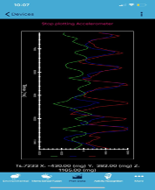 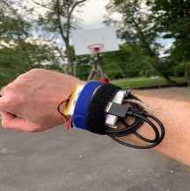

To maintain consistency we decided to take all shots from the free-throw line. With the SensorTile powered on and connected via Bluetooth to a smartphone, we logged each shot. Once the logging was stopped, the app generated an email with a .CSV files attached for the data from the accelerometer, magnetometer, and gyroscope. We then emailed the files to ourselves so they could be organized. Each file was labeled either Make, Miss Left, Miss Right, Miss Long, or Miss Short. The raw data was then copied to Google Drive for analysis.

Once we’d collected data, we needed to analyze it. Sishir applied the machine learning sequence (See Figure 3 above) in his analytics. As he completed his logistic regression modeling, he began with an initial accuracy score of 61% through the use of sklearn. Sishir tried to improve the accuracy through the use of normalization and scaling but found that there was diminished accuracy from these attempts. Ultimately, we learned that there was a class imbalance, and balancing the columns helped the scores to improve. Specifically, in their analytics, Ben and Sishir used K means clustering. Ben employs an approach in which the individual collecting data would take 5 shots per shooting episode and then take 1 step back away from the hoop. The shooter’s distance between the shooter and the hoop varied from 3 feet to 20 feet between episodes. Figure 5 below shows the results of our K means cluster with an average position of each group plotted. K means did a very nice job of showing how far a person shot from the hoop since we can see the data has a nice and even distribution.

**Figure 5**

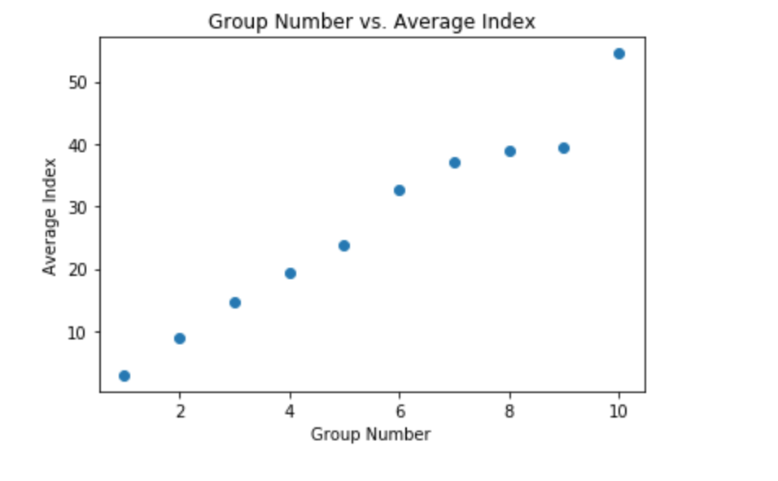

**Implementation: Hurdles and Lunges**

While we note our successes, they’d not all be met without learning from a few setbacks and surpassing some roadblocks along our journey. Early on our journey, we found some difficulty in Bluetooth (BLE) programming. We found the course learning resources as well as the extra time course staff invested in us during office hours helped to mentor us through this process. A second challenge was in sensor synchronization. Initially, we hoped to employ five sensors on the subject at different data collection points and to synchronize data collection from the sensors. We simply ran out of time to explore this worthy opportunity, but certainly, find it worth researching in the future. We made the best of the time we had, however, and Ben, Brendan, and Gurleen collected data from a single sensor per event/episode but collecting at two different episode locations (hand and wrist). Finally, the User Interface programming presented Diana with its own unique set of challenges. We wanted to work with Python language, but also wanted a user-friendly platform that would be easily adaptable for Android/IOS. Of course, while Python is strong in machine learning it is not well supported by Android and IOS. Diana overcame this issue by installing on Raspberry Pi so that the application could run on a more portable system. In the future, we might wish to continue to look for other libraries that would enable installation more readily into Android/IOS. Perhaps the greatest lesson is perseverance. When working with wearable devices, expect there to be hurdles or setbacks. The success of the project is not determined by whether or not you meet those obstacles but how you clear those hurdles and what you learn from the experience. We believe we learned much from each hurdle as well as each crossing.

**CONCLUSIONS**

The mechanics of shooting a basketball have been optimized and are well understood. A coach can tell you the motion and position of every body part throughout the shot. A problem arises when taller players or players with limited mobility try to replicate this motion. Most players will adapt their motion to accommodate their body. For instance, Kobe Bryant didn't point his feet at the hoop to allow for the range of motion of his elbow, Shaq can't bend his wrist due to a childhood injury, Durant can't place the ball at a point on his forehead while maintaining a reasonable bend of his elbow, and even Steph Curry places the ball below his chin as he starts his motion. Historically great shooters such as Peja Stojakovic, and Larry Bird incorporated the off-hand, and the only suggestion a coach could give them is to stop using their off-hand. With this in mind, a coach should assist a shooter by understanding their muscle control, stature, and quirks. In this paper, we share the results of our experimental project on a wearable device that combines machine learning and digital sensor processing to provide optimized and customized coaching to the basketball shooter. This paper reports on the vision of our project-Adaptive Basketball Coach (ABC)—by Treaty Bio, its accomplishments, and also some areas for further future improvements.